Adoption Application

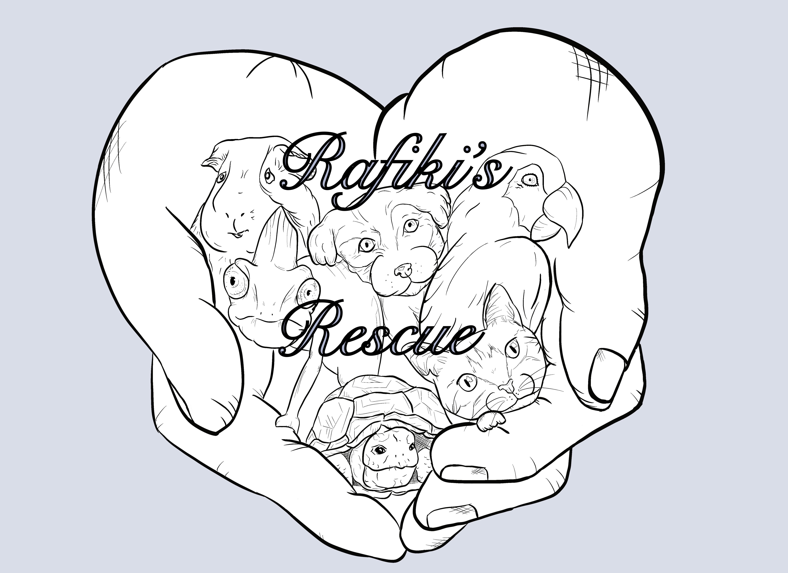
“What greater gift than the love of an animal...”

Date ________________________________

Name________________________________

Home Phone #________________________________

Cell Phone #____________________________

Email___________________________________________________________

Address _______________________________________________________________

________________________________________________________________

Driver’s License # ________________________________

Name of the reptile/amphibian (s) you want to adopt:
_____________________________________________________________________

Is this pet for you or a gift? ________________________________

If a gift, for whom ________________________________

Why are you adopting a reptile/amphibian? _______________________________________________________________________________________________________________________________________________________________________________________________________________________________________________________________________________________________________________________________________

Are you: Married/Single/Widowed

Age : _____________________

Occupation ________________________________

Co-Applicant (i.e., Spouse, Significant Other)?

_____________________________________________________________________________________________________________

Do you live in: Apt/House/Townhouse/Guesthouse/Condo/Mobile Home
Do you: Rent/Own

Rent/ Mortgage amount : ______________

How long have you been at this address ? ________ years ________months

Does your landlord allow pets? Yes/No

Do you work ?: Yes/No, If so, do you work from home: Yes/No

Do you have any objections to to a Rafiki’s Rescue representative visiting your home? Yes/No
Has anyone in your household been charged with animal cruelty or neglect? Yes/No

Please list all of the people living in your household
Name | Sex | Age

Do you currently own any pets: Yes/No
If “Yes” please provide all information:
Name | Breed | Age | Vaccinated | Spayed/  Neutered

What enclosure do you plan to use for this pet? Please describe in detail including substrate ____________________________________________________________________________________________________________________________________________________________________________________________________________________________________________________________________________________________________________________________________________

What type of lighting/heat source do you plan to use for this pet? Please describe in detail _____________________________________________________________________________________________________________

Will this pet be given time out of their enclosure? If so, please describe? ____________________________________________________________________________________________________________

When you travel, what do you do with your pets?
___________________________________________________________________________________________________________

Do you obtain regular medical care for your pet(s)? Yes/No
Veterinarian Name ________________________________
Address___________________________________________
Phone ____________________________________________

Please describe any outdoor access

_____________________________________________________________________________________________

—————————————————————————————————————————
How many reptiles/amphibians have you owned in the past 5 years? ________
What kinds_____________________________________________

What happened to them? _____________________________________________________________________________________________

__________________________________________________________________________________

What food do you plan to feed this pet (s)? ______________________________________

Have you ever given up a pet? Yes/No If yes, briefly describe the circumstances ___________________________________________________________________________________________________________________________________________________________________________________________________________________________________________________________________________________________________________________________________________________________________________________________________________________________________________________

If you could no longer care for your pet(s), what would you do with him/her/them?
_________________________________________________________________________________________________________________________________________________________________________________________________________________________

Do you have a plan in place in case you become ill or pass away for your pets to be taken care? __________________________________________________________________________________________________________________________________________________________________________________________________________________________

If your pet was missing, lost, or stolen, please briefly describe what you would do:
_________________________________________________________________________________________________________________________________________________________________________________________________________________________

Have you ever surrendered your pet to a county kill shelter or ASPCA Humane Society or similar no-kill shelter? Yes/No If yes, briefly explain the circumstances:

_________________________________________________________________________________________________________________________________________________________________________________________________________________________

Have you ever been denied pet ownership from a rescue organization or animal shelter? Yes/No, if yes please provide a brief explanation:

_________________________________________________________________________________________________________________________________________________________________________________________________________________________

If your reptile/amphibian) became sick, would you put a cap on an amount to get him/ her well?
____________________________________________________________________________________________________________

If so, what would that amount be? _________________

Please provide us with at least 3 personal references with whom you are NOT related to:

Name | Years known | Phone

Please initial the following:

------ I understand that the information on this application is kept confidential and is for the sole purpose of the pet adoption application process.

------I understand that a home check upon acceptance of this application by a certified rescue in your area.

------------------------------------------------
Signature of Applicant

------------------------------------------------
Signature of Co-Applicant (i.e., Spouse)

